**Operating System - Assignment - 4**

***Q.1 Consider the following page reference sequence:***

***1, 2, 3, 4, 2, 1, 5, 6, 2, 1, 2, 3, 7, 6, 3, 2, 1, 2, 3, 6.***

***Indicate the number of page faults that would occur assuming one, two, three, four, five, six, or seven frames using the following replacement algorithms:***

***• LRU replacement***

***• FIFO replacement***

***Note: Remember all frames are initially empty, so your first unique pages will all cost one fault each***

**Answer:**

|  |  |  |  |  |  |  |  |
| --- | --- | --- | --- | --- | --- | --- | --- |
| Frames | 1 | 2 | 3 | 4 | 5 | 6 | 7 |
| LRU | 20 | 18 | 15 | 10 | 8 | 7 | 7 |
| FIFO | 20 | 18 | 16 | 14 | 10 | 10 | 7 |

***Q.2 A system uses a dynamic partitioning scheme, and the current memory configuration is as shown below.***

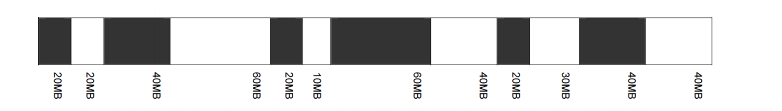

***The shaded areas are allocated blocks. The unshaded areas are free blocks. The next three memory requests are for 40MB, 20MB, and 60MB.***

***Indicate the starting address for each of the three blocks using the specified placement algorithm:***

**Answer:**

a)First-fit :

|  |  |
| --- | --- |
| Memory Request | Starting Address |
| 40MB | 80MB |
| 20MB | 20MB |
| 60MB | There will not be enough contiguous memory available to accommodate 60MB |

b)Best-fit :

|  |  |
| --- | --- |
| Memory Request | Starting Address |
| 40MB | 230MB |
| 20MB | 120MB |
| 60MB | 80MB |

c)Next-fit :

|  |  |
| --- | --- |
| Memory Request | Starting Address |
| 40MB | 360MB |
| 20MB | 20MB |
| 60MB | 80MB |

d)Worst-fit :

|  |  |
| --- | --- |
| Memory Request | Starting Address |
| 40MB | 80MB |
| 20MB | 230MB |
| 60MB | There will not be enough contiguous memory available to accommodate 60MB |

***Ques 3: Consider a logical address space of 64 pages of 1024 words each, mapped onto a physical memory of 32 frames.***

***a. How many bits are there in the logical address?***

**Answer:** 16 bits

***b. How many bits are there in the physical address?.***

**Answer:** 15 bits

***Ques 4: Consider the following segment table:***

***Segment Base Length***

***0 219 600***

***1 2300 14***

***2 90 100***

***3 1327 580***

***4 1952 96***

***What are the physical addresses for the following logical addresses?***

***a. 0,430***

***b. 1,10***

***c. 2,500***

***d. 3,400***

***e. 4,112***

**Answer:**

a.219 + 430 = 649

b.2300 + 10 = 2310

c.illegal reference, trap to operating system

d.1327 + 400 = 1727

e.illegal reference, trap to operating system